Practical 4 -
Code -
#include <iostream>
using namespace std;

class Node {
public:
string task_name;
int priority;
int exe_time;
Node* next;

Node(string task, int p, int exe) {
task_name = task;
priority = p;
exe_time = exe;
next = nullptr;
}

void display() {
cout << "Task Name: " << task_name << "Priority: "<<priority<<"Execution Time: "<<exe_time<<endl;

}

void insert(Node *&head, Node *newNode) {

if (head == nullptr || newNode->priority > head->priority) {
newNode->next = head;
head = newNode;
}

else if (newNode->priority == head->priority) {
Node* temp = head->next;
newNode->next = temp;
head->next = newNode;
}
else {

Node* temp = head;
while (temp->next != nullptr && temp->next->priority >= newNode->priority) {
temp = temp->next;
}
newNode->next = temp->next;
temp->next = newNode;
}
}

void execution(Node *&head, Node *newNode){
if (head == nullptr || newNode->priority > head->priority) {
newNode->next = head;
head = newNode;
}

else if (newNode->priority == head->priority) {
Node* temp = head->next;
newNode->next = temp;
head->next = newNode;
}
else {

Node* temp = head;
while (temp->next != nullptr && temp->next->priority >= newNode->priority) {
temp = temp->next;
}
newNode->next = temp->next;
temp->next = newNode;
}
}
};

int main() {
Node* head = nullptr;
Node* newNode;
int n;
string t;
int pr;
int ex;

cout << "Enter the number of tasks to schedule: ";
cin >> n;
int x;
cout<<"Priority should be according to which order - 1.Priority 2.Execution time"<<endl;
cin>>x;
if(x==1){
for (int i = 0; i < n; i++) {
cout << "Task Name: ";
cin >> t;
cout << "Priority (higher = more important): ";
cin >> pr;
cout << "Execution Time (ms): ";
cin >> ex;

newNode = new Node(t, pr, ex);
head->insert(head, newNode);
}

cout<<"Scheduled Tasks (Highest Priority First): "<<endl;
Node* temp = head;
while (temp != nullptr) {
temp->display();
temp = temp->next;
}
}
else{
for (int i = 0; i < n; i++) {
cout << "Task Name: ";
cin >> t;
cout << "Priority (higher = more important): ";
cin >> pr;
cout << "Execution Time (ms): ";
cin >> ex;

newNode = new Node(t, pr, ex);
head->insert(head, newNode);
}

cout<<"Executing Tasks according to execution time(lower execution time will have higher priority): "<<endl;
Node* temp = head;
while (temp != nullptr) {
temp->display();
temp = temp->next;
}

}
return 0;
}

Output -
- Priority order -
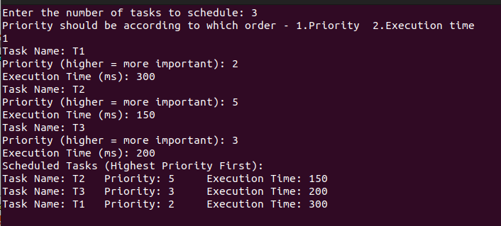

- Execution Order -
